Wolf Den Land Trust
Blue Flag Meadow Property
Hampton, CT
Habitat Management Plan
With Focus on Young Forest Wildlife

Submitted October 4, 2017

Lisa Wahle, Contract Biologist, and Andrea Petrullo, Technical Assistant

Wildlife Management Institute/ CT Department of Environmental Protection
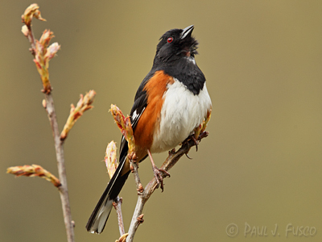
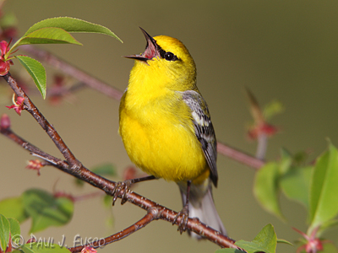

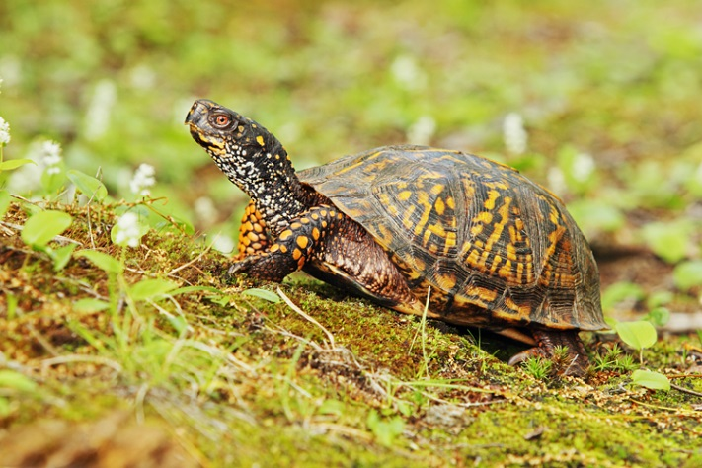
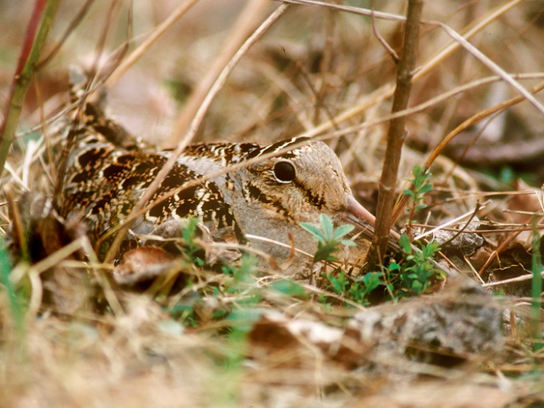
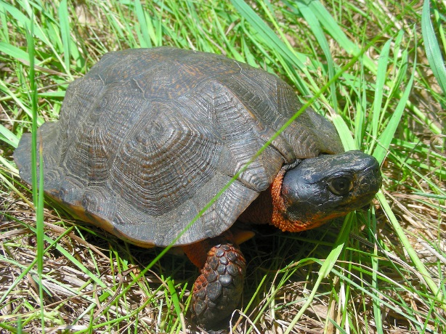
Introduction: Young forest wildlife – Need for habitat
Clockwise from top left:
Eastern towhee, American woodcock, Blue-winged warbler, Eastern box turtle, Paul Fusco, CT DEEP
Wood turtle, JD Mays
Although wildlife can benefit from various types of forest management, the focus of this document is on creating and sustaining habitat for species that require large patches of shrubland or young forest.
Over the last century, the Northeastern United States has witnessed a decline in young forest, with a subsequent loss of wildlife that depend on this type of habitat. Young forest is critical to more than 50 species of greatest conservation need (GCN) in Connecticut, while many more species use this habitat during some part of their lives. GCN species account for those listed as endangered, threatened and special concern, and also species in decline and for which Connecticut has regional or global responsibility. (See the Connecticut Wildlife Action Plan for a complete discussion of GCN species, http://www.ct.gov/deep/cwp/view.asp?a=2723&q=325886&deepNav_GID=1719). The GCN species that require young forest include New England cottontail, American woodcock, ruffed grouse, eastern towhee, eastern box turtle, wood turtle plus many other song birds, amphibians, reptiles, butterflies, moths and various insects (Appendix 1).

Regional recovery plans have been developed for New England cottontail (NEC) and American woodcock, and Focus Areas have been designated to prioritize recovery efforts (Figure 1). For almost all young forest wildlife the cause of decline is the same: loss of habitat. Restoration of suitable habitat is key to species recovery. The Blue Flag Meadow property is located within four miles of the Scotland-Canterbury NEC focus area. It is within the statewide American woodcock focus area, and woodcock have often been observed displaying in the fields during spring. While this project is designed using the site criteria and considerations for woodcock, many species will benefit from the habitat management. It should be noted that an NEC was collected approximately two kilometers northwest of the property in 2002. Although the preserve is not within an NEC Focus Area, it is possible that NECs exist in the area and may also benefit from habitat improvements.

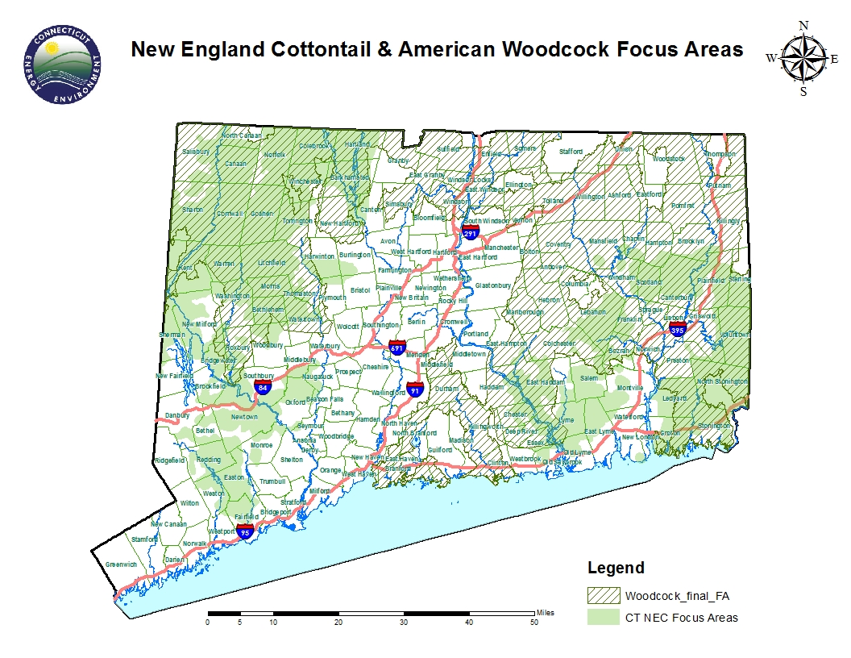
American woodcock require large patches of shrubland or young forest for nesting and feeding cover. They feed in rich, moist soils during the day, where earthworms make up most of their diet. Males also require grassy openings for singing and displaying to attract mates. At night, woodcock hide or roost in places that have patchy dense cover with occasional openings so they can take flight if pursued by a mammalian predator. Even though the birds can fly between displaying, feeding and roosting locations, it is ideal if these functional areas are close together to avoid risk of predation between sites. The proposed project on the Blue Flag Meadow property would make a significant contribution to conservation of shrubland-dependent wildlife and will provide suitable habitat for American woodcock to breed and raise young. The property has rich and wet soils required for feeding, and will have, after management, the various habitat components to support these birds through their breeding and brood rearing cycle.
Figure 1.
Blue Flag Meadow Property

The following site description and proposal are based largely on the Forest Management plan written by Joshua (Josh) Miller (2017), and a site walk conducted on August 7 with Josh, Steve Broderick of the Wolf Den Land Trust (WDLT) and Eastern Connecticut Forest Landowner’s Association (ECFLA), and WMI/CTDEEP contract biologist, Lisa Wahle, and return visits on August 15 by Josh and Andrea Petrullo, and September 5 by Josh and Lisa.

Site Description:
Location and Landscape Setting: The Wolf Den Land Trust’s Blue Flag Meadow property is located in northern Hampton, with a very small portion in southeastern Eastford. The 92.7-acre parcel is bounded by Kenyon Road to the north and Stetson and Lewis Roads to the east. The property can be accessed from a driveway on Kenyon Road. Part of the Airline Trail runs southwest to northeast along the southern border. To the north and west is Natchaug State Forest; privately owned woodland and agricultural fields are found to the northeast, east and south. There are a number of ponds, wetlands and streams throughout the area (Figure 2).
Analysis of recent aerial photography indicates that approximately 10% of the landscape within three kilometers of the parcel is in some type of early successional habitat (e.g., field, reverting field, powerline corridor), providing suitable alternative sites for American woodcock.
Natural Diversity Database (NDDB) polygons, indicating CT species and/or ecological communities of concern, overlap approximately 70 acres of the property, including the pond (Figure 2). CT DEEP NDDB staff has clarified that these polygons represent a suite of invertebrates that occur in a poor fen west of the property, and wood turtles documented to the south and west. A full NDDB review will be conducted as part of the application process to the Natural Resources Conservation Service for funding of habitat management. Because Blue Flag Meadow is has old fields and shrubland that may serve as summer habitat for wood turtle, it is anticipated that there will be seasonal restrictions and site management recommendations from CT DEEP to minimize possible harm to these animals. But these recommendations should not hinder any proposed work.
Property Description: The highest elevation, at approximately 650 feet, is located along the western edge of the property near Kenyon Road. The terrain within the property boundaries is roughly bowl-shaped, with elevations of roughly 640-650 feet around the perimeter, sloping down towards the center of the property. The lowest elevation is 580 feet around the edges of the pond in the center of the property. Two brooks feed into the pond, one near the pond’s northern tip and the other in the southwestern part of the pond. A third brook drains out of the pond on the western side.
Mapped upland soils are of glacial till origin and include: Charlton-Chatfield complex, Paxton Montauk fine sandy loam, and Woodbridge fine sandy loam. Most of this is very stony to extremely stony, except for 15.7 acres of prime farmland soil consisting mostly of Woodbridge fine sandy loam. Wetland soils include approximately 22.3 acres of Ridgebury, Leicester, and Whitman along two drainages, and 2.6 acres of Catden and Freetown soils along the northwestern shore of the pond (Figure 4). Together, prime farmland and wetland soil, considered important to American woodcock, comprise 14 percent of the property. Within the proposed treatment area, wetland and farmland soils comprise 69 percent.
Historic Landuse: At one time, most of the property had been cleared for agriculture, probably hayfields and pasture, which were abandoned during the last century. Figure 9 shows the approximate property boundary overlain on a 1934 aerial photograph. A majority of the land west of the pond was agricultural fields, while the area east of the ponds appears to be shrubland.
Forest Stands: Stand 1, as identified in the 2017 Forest Management Plan by Miller (Figure 6,) is predominantly pole-sized red maple trees with several old wolf trees. It has a spicebush and mixed invasive understory of Japanese barberry, oriental bittersweet, winged euonymus and glossy buckthorn (Figure 7). Stand 6 is an open herbaceous meadow with few scattered trees and shrubs. It has a significant invasive plant component of oriental bittersweet, multiflora rose and autumn olive, but there are patches of native gray dogwood and young aspen (Figures 8 and 9). The field is presently mowed on a yearly basis, providing a singing and display area for woodcock. Stand 2 consists of sawtimber-sized red maple and ash with a Japanese barberry and spicebush understory. Stand 3 and 4 are a mix of large hardwoods, mostly oaks, and pole-size mixed hardwoods with a mixed native and invasive understory. Stand 5 is a tangle of invasive shrubs and vines with few live trees.
Pond shore: Inside the boundary of the mapped forest stands is pond’s wetland border. It is largely tussock sedge with a mix of native and invasive shrubs. Native species include highbush blueberry, winterberry, maleberry, sweet pepperbush, spicebush and buttonbush; the noted invasive shrub is glossy buckthorn (Figure 10).
Existing habitat: Existing shrub thicket is estimated to comprise approximately 6 percent of the land on the property. The densest areas are mostly invasive shrubs and vines occurring in the southern portion of Stand 5 (3 acres), as well as a dense understory of mostly invasive shrubs throughout Stands 1 and 2.
Figure 2. Blue Flag Meadow and Natural Diversity Database areas.
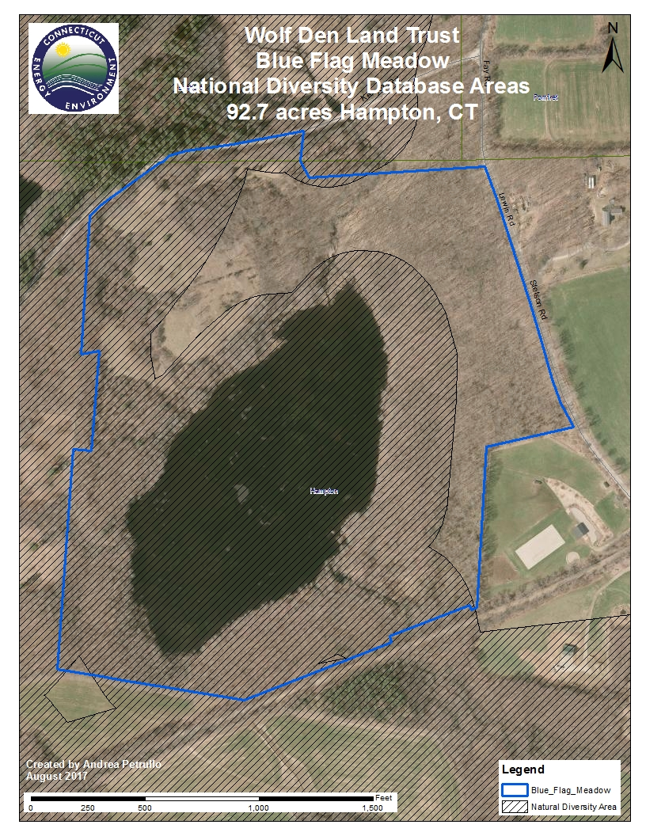
Figure 3. Blue Flag Meadow property, elevation contours and wetland soils.
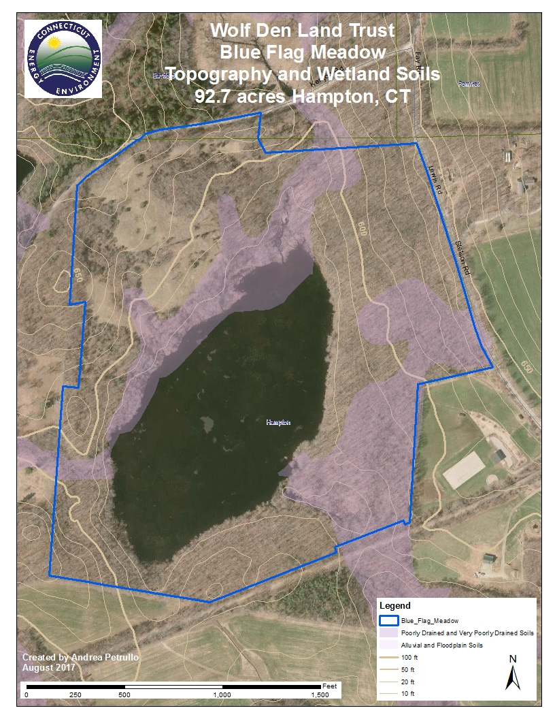
Figure 5. Blue Flag Meadow mapped soils 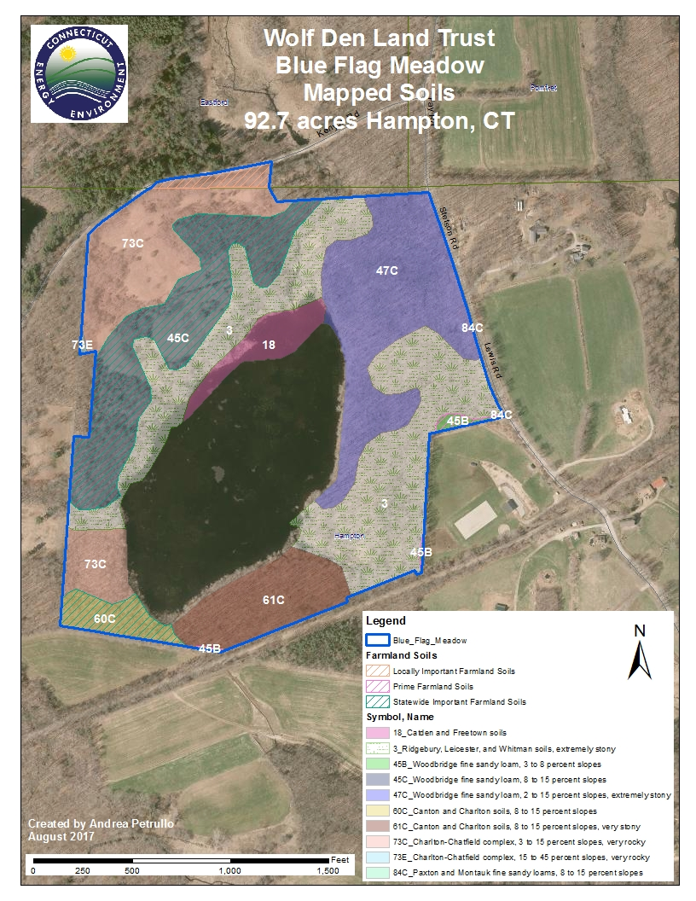
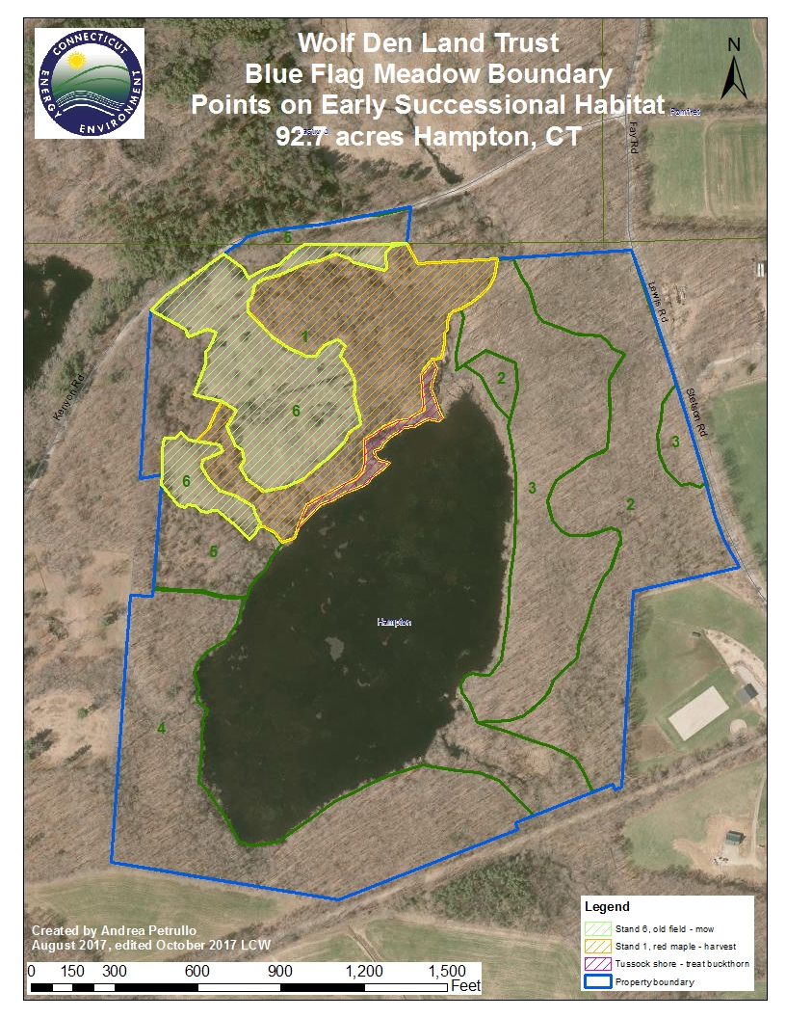
Figure 6. Forest stands identified Josh Miller (2017) in the Forest Management Plan, with habitat management area highlighted.
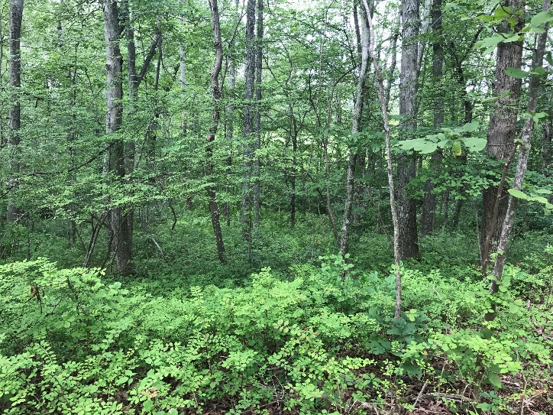
Figure 7. Spicebush understory in red maple-dominated Stand 1.

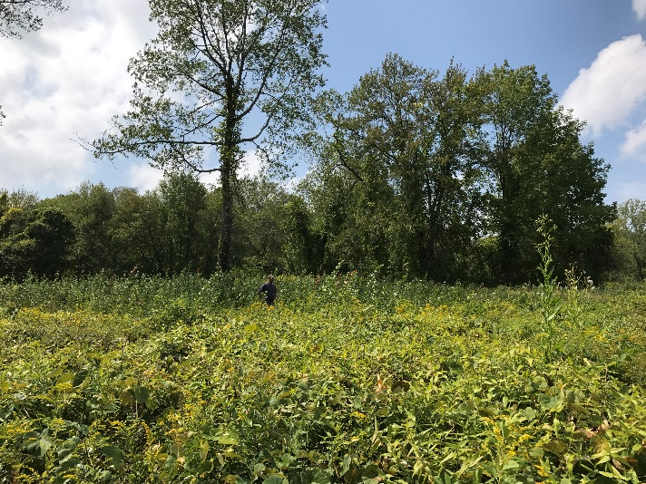
Figure 8. Open field area of Stands 6; Josh Miller standing in patch of regenerating aspen.

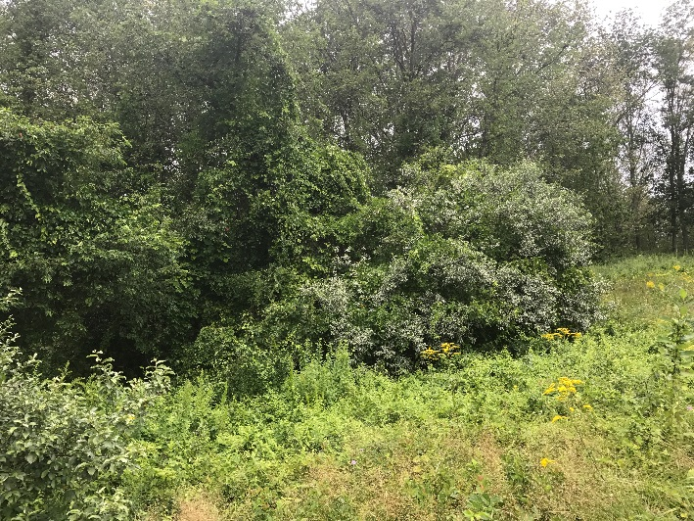
Figure 9. Invasive shrub and vine border of between open Stand 6 and Stand 1.

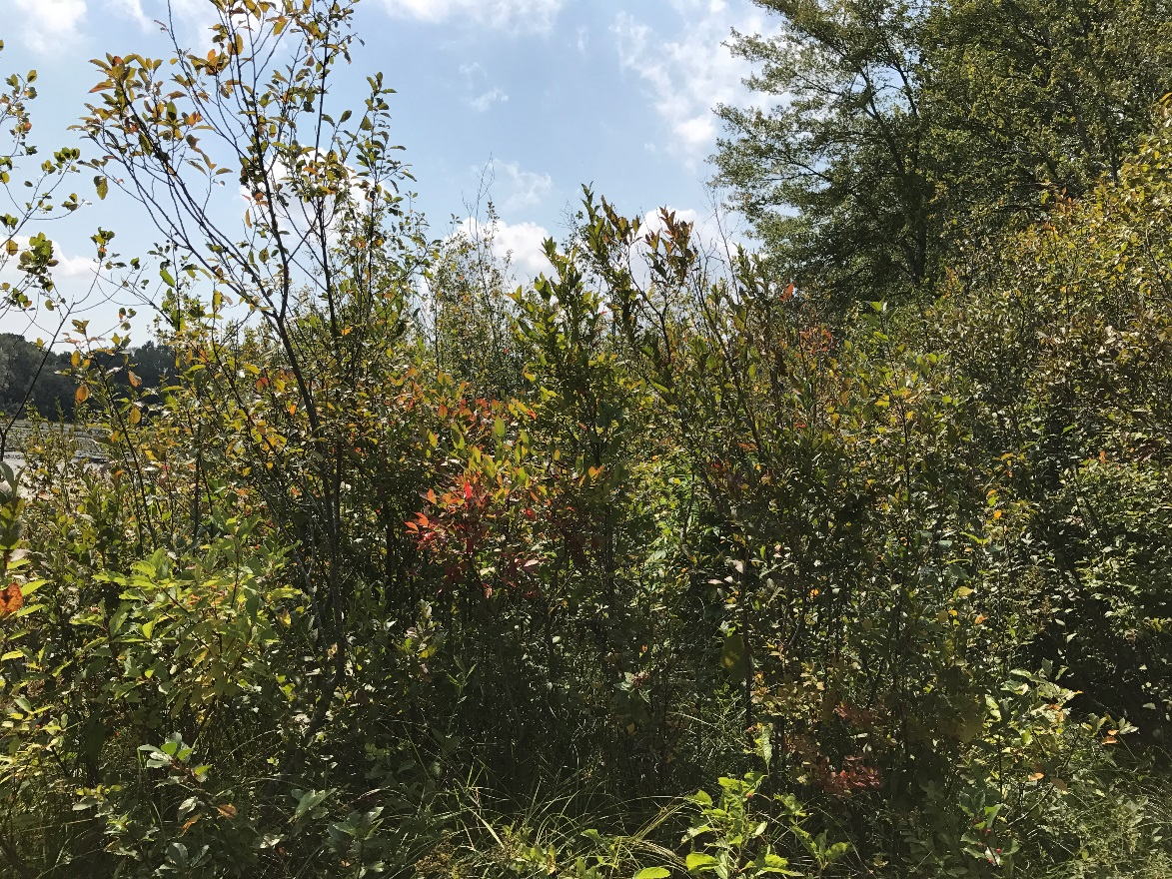
Figure 10. Tussock pond border with native shrubs and invasive glossy buckthorn.
Figure 9. Approximate boundary of Blue Flag Meadow shown on 1934 aerial photo.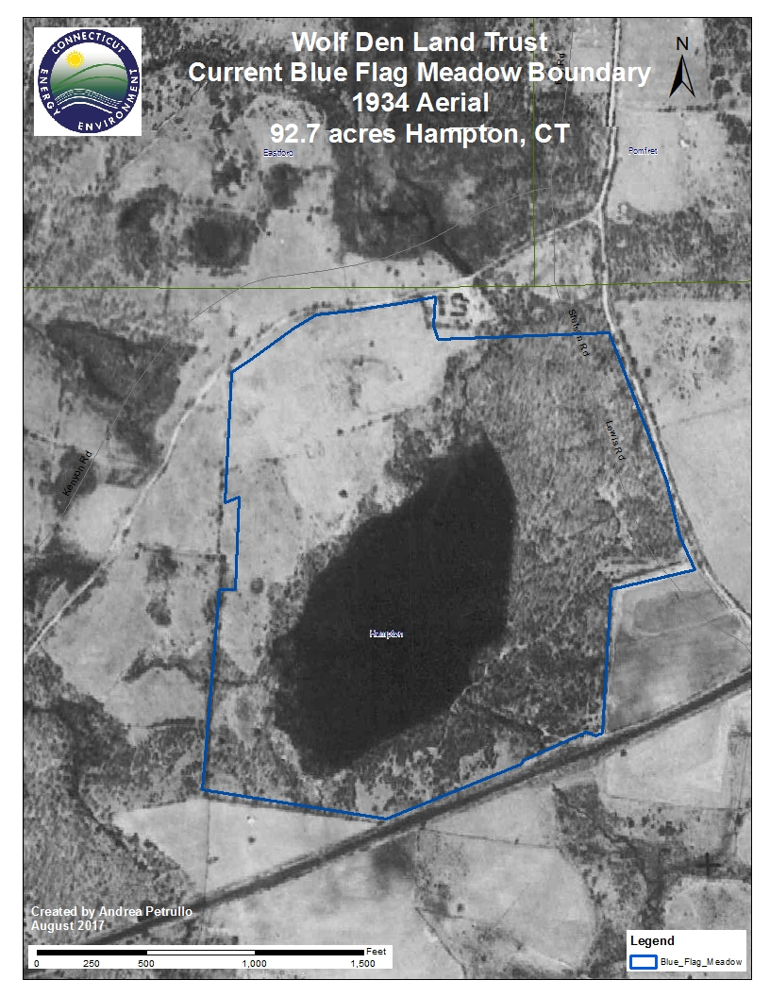
Management Recommendations TO PROMOTE REGENERATION OF YOUNG FOREST:
Tree cutting: Refer to Figure 6. The Miller Forest Management Plan (2017) calls for a silvicultural clearcut in Stand 1 (9.2 of 12 acres) in Year One to encourage regeneration of vigorous young forest. Given the soils and proximity to existing openings and cover, this stand is appropriate for clearing and regeneration as young forest habitat. The recommended treatment is to cut all trees greater than 2 inches in diameter except designated leave trees. Trees of exceptional aesthetic or wildlife value for cover and/or mast may be retained, not to exceed 25% canopy. Snags or old wolf trees may be left to provide dens or roosting cavities. Up to three brush piles per acre may be constructed to provide immediate cover in harvest areas, but this is not required.
Field mowing: Stand 6 is a mix of herbaceous plants with shrubs, vines, and scattered trees. It is currently cut yearly with a brush hog. This open area can provide roosting or singing grounds for woodcock, so we recommend continuing these practices in the future, but with some modification. Mowing can be decreased to every other year or, alternatively, the field could be mowed partially every year to promote a diversity of herbaceous plants and provide a fall seed source for migrating birds and other wildlife. Cedar trees that provide valuable cover and food for wildlife should be retained; and patches of gray dogwood and aspen may be left un-cut for several years to provide additional wildlife food and cover.
Invasive species control: Invasive shrubs and vines will need to be controlled in the tree-cutting area of Stand 1, the open meadow of Stand 6, and as much as possible in adjacent Stand 5. All areas will require and initial heavy herbicide treatment, with two years of follow-up. In Stand 1, initial treatments may occur before or after tree harvest. The benefit of treating before harvest is that it minimizes a flourish of invasive growth once the canopy is removed. Along the tussock pond edge, glossy buckthorn should be treated by cutting individual stems, followed immediately by herbicide application.
Timing: Invasive treatment should be conducted late in the growing season to maximize stress and kill of target plants. Ideally, the initial treatment should be done before canopy removal of Stand 1 as explained above. Tree cutting should occur between August 15 and April 1 to avoid nesting season. Note that if NRCS pays for all or some of the proposed management, further timing restrictions to protect State Special Concern wood turtle and the Federally Threatened Northern Long Eared Bat may apply. A schedule of proposed management is provided in Table 1.
Table 1. Recommended schedule for management actions.
Area | Acres | Area description | Proposed management | Timeline
Stand 1* | 9.2 | Pole-sized red maple, mixed hardwood legacy trees | - Conduct regeneration (clear) cut; retain several legacy trees; build brush piles if desired, up to 3/acre.  - Herbicide invasive understory; follow up treatments 2 more years | - Fall/Winter 2018-2019  - Late Summer 2018, 2019, 2020
Stand 6* | 8.7 | Open meadow, mix of broad-leaved herbs and grasses, invasive shrubs and vines with patches of native woody plants. | - Mow field every other year or mow field partially every year; allow patches of dogwood and aspen to grow for several years  - Herbicide invasive shrubs and vines with 2 years of follow-up | - Late summer 2018, (2019 if partial mowing), 2020  - Late Summer/ early fall 2018, 2019, 2020
Tussock pond edge | 0.75 | Tussock sedge with mix of native and invasive wetland shrubs. | - Hand cut glossy buckthorn and treat stumps immediately with herbicide | - Late summer/ fall 2018
*Forest stands designated Miller Forest Stewardship Plan, 2017-2027.

REFERENCES:
Connecticut Department of Energy and Environmental Protection, Division of Wildlife. 2012. Management Plan for American woodcock in Connecticut.
Fuller, S. and A. Tur. 2012. Conservation Strategy for the New England cottontail (Sylvilagus transitionalis). https://newenglandcottontail.org/sites/default/files/conservation_strategy_final_12-3-12.pdf
Gilbart, Meghan. 2012. Under Cover: Wildlife of Shrublands and Young Forest. Wildlife Management Institute. Cabot VT. 87 pages. https://youngforest.org/sites/default/files/Under_Cover-010412_FINAL.pdf
Miller, Joshua. Draft September 2017. Forest Management Plan, Blue Flag Meadow Property.
Rodewald, P. (Editor). 2015. The Birds of North America: https://birdsna.org. Cornell Laboratory of Ornithology, Ithaca, NY.
U.S. Department of Agriculture, Natural Resources Conservation Service. 2010. American Woodcock: Habitat Best Management Practices for the Northeast by Scot J. Williamson. Wildlife Insight. Washington, DC. https://timberdoodle.org/sites/default/files/northern_forest_woodcock_bmp_nrcs_wildlife_insight.pdf
Appendix 1: CT Species of Greatest Conservation Need Dependent on Young Forest / Shrubland. Source: CT State Wildlife Action Plans (SWAP) 2005 and 2015.
2005 CT SWAP | 2015 CT SWAP |  | 2005 CT SWAP (cont.) | 2015 CT SWAP (cont.)
 |  |  | Gray Catbird
Buckmoth | Buckmoth |  | Hooded Warbler
Barren Dagger Moth | Barren Dagger Moth |  | Indigo bunting | Indigo bunting
Barrens Metarranthis moth | Barrens Metarranthis moth |  | Magnolia Warbler
Frosted Elfin | Frosted Elfin |  | Northern Bobwhite
Henry's Elfin | Henry's Elfin |  | Olive-sided Flycatcher
Mottled Duskywing | Mottled Duskywing |  | Orchard Oriole
Persius duskywing | Persius duskywing |  | Prairie Warbler | Prairie Warbler
Phyllira tiger moth | Phyllira tiger moth |  | Ruffed Grouse | Ruffed Grouse
Pine Barrens Tiger Beetle | Pine Barrens Tiger Beetle |  | Veery | Veery
Pine Barrens itame | Pine Barrens itame |  | Whip-poor-will | Whip-poor-will
Pine barrens zanclognatha moth | Pine barrens zanclognatha moth |  | White-eyed Vireo | White-eyed Vireo
Pine Pinion moth | Pine Pinion moth |  | Willow Flycatcher | Willow Flycatcher
Regal Fritillary | Regal Fritillary |  | Yellow-Billed Cuckoo | Yellow-Billed Cuckoo
Sleepy Duskywing | Sleepy Duskywing |  | Yellow-Breasted Chat | Yellow-Breasted Chat
14 | Monarch |  | 28 | 21
 | Rusty patch bumble bee |  | Bobcat | Long-tailed Weasel
 | Toothed Apharetra |  | Long-tailed Weasel | New England Cottontail
 | 17 |  | New England Cottontail | Short-tailed Weasel
 |  |  | Short-tailed Weasel | Southern Red-backed Vole
 |  |  | Southern Red-backed Vole | Woodland Jumping Mouse
Alder Flycatcher | Alder Flycatcher |  | Woodland Jumping Mouse | 5
American Woodcock | American Woodcock |  | 6
Bay-breasted Warbler |  |  | Eastern Box Turtle | Eastern Box Turtle
Black-billed Cuckoo | Black-billed Cuckoo |  | Eastern Hognose snake | Eastern Hognose snake
Blue-winged Warbler | Blue-winged Warbler |  | Eastern Spadefoot | Eastern Spadefoot
Brown Thrasher | Brown Thrasher |  | Fowler's toad | Fowler's toad
Canada Warbler | Canada Warbler |  | Five-lined Skink | North American Racer=Eastern Racer
Chestnut-sided Warbler | Chestnut-sided Warbler |  | North American Racer | Smooth Green Snake
Common nighthawk | Common nighthawk |  | Smooth Green Snake | Spotted Turtle
Eastern Kingbird | Eastern Kingbird |  | Spotted Turtle | Timber Rattlesnake
Eastern Towhee | Eastern Towhee |  | Timber Rattlesnake | Eastern Ribbon Snake
Field Sparrow | Field Sparrow |  | 9 | 9
Golden-winged Warbler | Golden-winged Warbler |  | TOTAL = 56 | TOTAL = 52

